What is Cloud Computing?
Introduction
Cloud Computing is one of the most significant technological advancements in the field of Information Technology. It refers to the delivery of computing services such as servers, storage, databases, networking, software, analytics, and intelligence over the Internet, commonly known as "the cloud." Instead of purchasing, owning, and maintaining physical data centers and servers, organizations can access technology services from cloud providers on an as-needed basis.
Cloud computing has transformed the way businesses and individuals store, manage, and process data. It offers flexibility, scalability, reliability, and cost-effectiveness, making it a preferred solution for modern computing needs. Today, organizations of all sizes rely on cloud computing to support applications, manage workloads, and improve business efficiency.
History of Cloud Computing
The concept of cloud computing originated from the idea of utility computing, where computing resources could be provided as a service similar to electricity or water. In the 1960s, computer scientist John McCarthy suggested that computing resources might someday be organized as a public utility.
The evolution of cloud computing accelerated with the growth of the Internet. During the late 1990s and early 2000s, companies began offering hosted services over the web. In 2006, Amazon introduced Amazon Web Services (AWS), which marked a major milestone in cloud computing. Following this, Microsoft Azure, Google Cloud Platform, and many other cloud providers emerged, making cloud services widely accessible.
Today, cloud computing serves millions of users worldwide and supports technologies such as Artificial Intelligence, Big Data Analytics, the Internet of Things (IoT), and Machine Learning.
Definition of Cloud Computing
According to the National Institute of Standards and Technology (NIST), cloud computing is a model that enables convenient, on-demand network access to a shared pool of configurable computing resources such as networks, servers, storage, applications, and services that can be rapidly provisioned and released with minimal management effort.
In simple terms, cloud computing allows users to access computing resources over the Internet without managing the underlying hardware infrastructure.
How Cloud Computing Works
Cloud computing operates through a network of remote servers hosted on the Internet. These servers store, process, and manage data. Users access cloud services through web browsers, mobile applications, or APIs.
When a user requests a cloud service, the cloud provider allocates the necessary resources from its data centers. Virtualization technology enables multiple users to share the same physical infrastructure efficiently while maintaining security and isolation.
The cloud service provider manages hardware, software updates, security, maintenance, and resource allocation, allowing users to focus on their applications and business operations.
Characteristics of Cloud Computing
1. On-Demand Self-Service
Users can provision computing resources whenever required without human interaction from the service provider.
2. Broad Network Access
Cloud services are accessible through the Internet using various devices such as computers, smartphones, tablets, and laptops.
3. Resource Pooling
Cloud providers pool computing resources to serve multiple users through a multi-tenant model.
4. Rapid Elasticity
Resources can be scaled up or down quickly depending on demand.

5. Measured Service
Cloud systems automatically monitor and optimize resource usage, enabling a pay-as-you-go pricing model.
Architecture of Cloud Computing
Cloud computing architecture consists of two major components:
Front-End
The front-end includes client devices, web browsers, mobile applications, and user interfaces through which users interact with cloud services.
Back-End
The back-end includes servers, storage systems, databases, virtualization software, management tools, and security mechanisms maintained by cloud providers.
The Internet acts as the communication medium between the front-end and back-end components.
Service Models of Cloud Computing
Infrastructure as a Service (IaaS)
IaaS provides virtualized computing resources such as servers, storage, and networking.
Examples:
- Amazon EC2
- Microsoft Azure Virtual Machines
Benefits:
- High scalability
- Reduced hardware costs
- Flexible resource allocation
Platform as a Service (PaaS)
PaaS provides a development and deployment platform for applications.
Examples:
- Google App Engine
- Heroku
Benefits:
- Faster development
- Reduced infrastructure management
- Improved productivity
Software as a Service (SaaS)
SaaS delivers software applications over the Internet.
Examples:
- Gmail
- Microsoft 365
- Salesforce
Benefits:
- Easy access
- No installation required
- Automatic updates
Deployment Models of Cloud Computing
Public Cloud
Services are provided over the public Internet and shared among multiple users.
Advantages:
- Cost-effective
- Easy deployment

Private Cloud
Cloud infrastructure is dedicated to a single organization.
Advantages:
- Enhanced security
- Greater control
Hybrid Cloud
Combines public and private cloud environments.
Advantages:
- Flexibility
- Improved resource utilization
Community Cloud
Infrastructure is shared among organizations with similar requirements.
Advantages:
- Cost sharing
- Collaborative environment
Advantages of Cloud Computing
- Reduced operational costs.
- High scalability and flexibility.
- Faster deployment of applications.
- Improved collaboration.
- Automatic software updates.
- Enhanced disaster recovery.
- Global accessibility.
- Better resource utilization.
Disadvantages of Cloud Computing
- Dependence on Internet connectivity.
- Potential security and privacy concerns.
- Vendor lock-in issues.
- Limited control over infrastructure.
- Possibility of service outages.
- Compliance and regulatory challenges.
Applications of Cloud Computing
Cloud computing is used in various industries and applications, including:
- Data storage and backup
- Email services
- Online collaboration
- Video streaming platforms
- E-commerce websites
- Social networking applications
- Healthcare systems
- Educational platforms
- Banking and financial services
- Artificial Intelligence and Machine Learning
- Big Data Analytics
- Internet of Things (IoT)
Security Challenges in Cloud Computing
Despite its advantages, cloud computing faces several security challenges:
- Data breaches
- Unauthorized access
- Insider threats
- Malware attacks
- Data loss
- Compliance issues
To address these challenges, cloud providers implement encryption, authentication, access control mechanisms, and regular security audits.
Future Scope of Cloud Computing
The future of cloud computing is promising due to the growing adoption of digital technologies. Emerging trends include:
- Serverless Computing
- Edge Computing
- Artificial Intelligence Integration
- Multi-Cloud Strategies
- Cloud-Native Applications
- Green Cloud Computing
- Quantum Computing Integration
As organizations continue their digital transformation journey, cloud computing will remain a critical technology for innovation and business growth.
Conclusion
Cloud Computing has revolutionized the way computing resources are delivered and consumed. It provides scalable, flexible, and cost-effective solutions for individuals and organizations. Through various service models and deployment models, cloud computing supports a wide range of applications across different industries. Although security and privacy challenges exist, continuous advancements in cloud technologies are making cloud environments more secure and efficient.

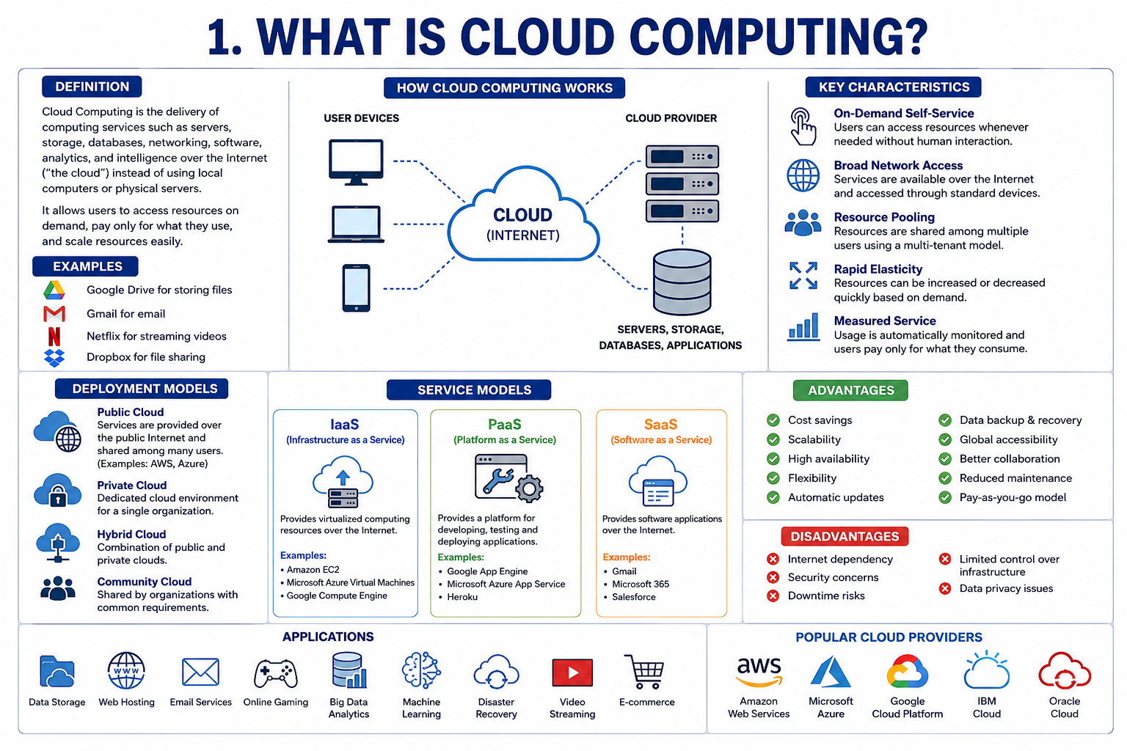

What are the Advantages of Microsoft Azure?
Introduction
Microsoft Azure is a cloud computing platform and service developed by Microsoft. It provides a wide range of cloud services, including computing, storage, networking, databases, analytics, artificial intelligence, and security. Organizations use Microsoft Azure to build, deploy, and manage applications through Microsoft's global network of data centers.
Azure has become one of the leading cloud platforms in the world because of its flexibility, scalability, security, and integration with Microsoft products. Businesses, educational institutions, government agencies, and startups use Azure to improve efficiency, reduce costs, and accelerate digital transformation.

Overview of Microsoft Azure
Microsoft Azure was launched in 2010 and has grown into a comprehensive cloud platform offering hundreds of services. It supports multiple programming languages, operating systems, databases, and frameworks, making it suitable for a variety of applications.
Azure provides Infrastructure as a Service (IaaS), Platform as a Service (PaaS), and Software as a Service (SaaS) solutions. This allows organizations to choose the level of control and management that best suits their requirements.
Advantages of Microsoft Azure
1. Scalability and Flexibility
One of the biggest advantages of Microsoft Azure is its ability to scale resources according to business needs. Organizations can easily increase or decrease computing power, storage, and network resources without purchasing additional hardware.
Benefits:
- Supports business growth.
- Handles sudden traffic increases.
- Reduces infrastructure limitations.
2. Cost-Effectiveness
Azure follows a pay-as-you-go pricing model. Users pay only for the resources they consume, eliminating the need for large upfront investments in hardware and software.
Benefits:
- Lower capital expenditure.
- Reduced maintenance costs.
- Better resource utilization.
3. High Availability and Reliability
Microsoft Azure offers highly available services through multiple data centers distributed across the world. It provides backup systems and redundancy to ensure continuous service availability.
Benefits:
- Reduced downtime.
- Improved business continuity.
- Reliable application performance.
4. Strong Security Features
Security is a major focus of Microsoft Azure. It provides advanced security tools and services to protect data, applications, and infrastructure.
Security Features:
- Data encryption.
- Multi-factor authentication.
- Identity and access management.
- Threat detection and monitoring.
- Security compliance certifications.
Benefits:
- Protection against cyber threats.
- Enhanced data privacy.
- Secure access control.
5. Global Presence
Azure operates through a vast network of data centers located in different regions around the world. Organizations can deploy applications closer to users to improve performance.
Benefits:
- Faster application response times.
- Reduced latency.
- Improved user experience.

6. Integration with Microsoft Products
Azure integrates seamlessly with Microsoft products such as:
- Windows Server
- Active Directory
- Microsoft 365
- SQL Server
- Visual Studio
Benefits:
- Easy migration of existing applications.
- Familiar environment for IT professionals.
- Improved productivity.
7. Disaster Recovery and Backup
Azure provides powerful backup and disaster recovery solutions that help organizations recover data and applications quickly after failures or disasters.
Benefits:
- Data protection.
- Faster recovery times.
- Business continuity.
8. Hybrid Cloud Support
Azure supports hybrid cloud environments by allowing organizations to combine on-premises infrastructure with cloud resources.
Benefits:
- Greater flexibility.
- Better resource management.
- Smooth cloud migration.
9. Advanced Analytics and Artificial Intelligence
Azure offers services for Artificial Intelligence (AI), Machine Learning (ML), and Big Data Analytics.
Examples:
- Azure Machine Learning
- Azure Cognitive Services
- Azure Synapse Analytics
Benefits:
- Better decision-making.
- Data-driven insights.
- Intelligent application development.
10. Developer-Friendly Platform
Azure supports various programming languages and development tools, including:
- Python
- Java
- C#
- JavaScript
- Node.js
- PHP
Benefits:
- Faster application development.
- Easy deployment.
- Support for modern development practices.
11. Automatic Updates and Maintenance
Microsoft manages hardware maintenance, software updates, and infrastructure monitoring.
Benefits:
- Reduced administrative burden.
- Improved system performance.
- Enhanced security.
12. Compliance and Regulatory Support
Azure complies with numerous international standards and regulations.
Benefits:
- Easier compliance management.
- Suitable for industries with strict regulations.
- Increased customer trust.
Real-World Applications of Microsoft Azure
Microsoft Azure is widely used for:
- Website hosting
- Mobile application development
- Data storage and backup
- Artificial Intelligence applications
- Internet of Things (IoT) solutions
- Business analytics
- Enterprise application hosting
- Disaster recovery services
- Virtual machine deployment
- Database management
Challenges of Microsoft Azure
Although Azure offers many benefits, some challenges include:
- Learning curve for beginners.
- Internet dependency.
- Complex pricing structure.
- Vendor lock-in concerns.
However, these challenges are generally outweighed by the platform's advantages.
Conclusion
Microsoft Azure is one of the most powerful and widely used cloud computing platforms available today. It provides scalability, flexibility, security, reliability, and cost-effective solutions for organizations of all sizes. Its integration with Microsoft technologies, strong security framework, global infrastructure, and support for advanced technologies such as Artificial Intelligence and Machine Learning make it a preferred choice for modern businesses. As cloud adoption continues to grow, Microsoft Azure will remain a key platform for digital transformation and innovation.
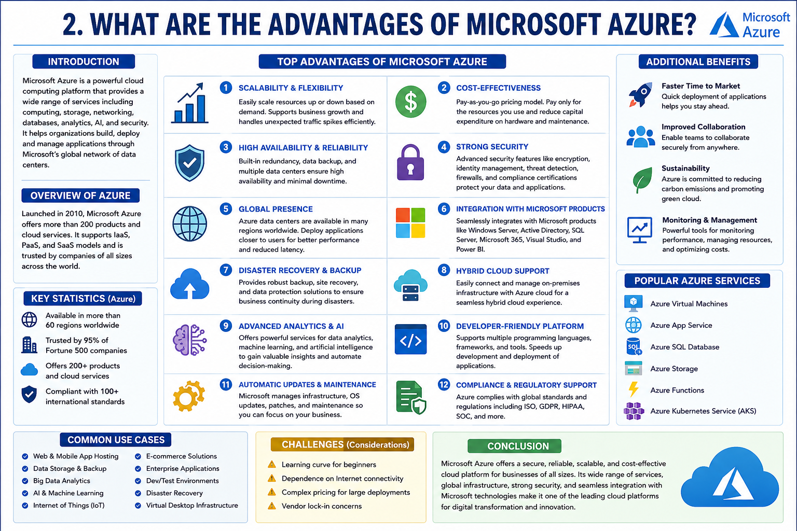

What is Hosting in Azure?
Introduction
Hosting is the process of storing and running websites, web applications, databases, and other services on servers so that they can be accessed through the Internet. In traditional hosting environments, organizations need to purchase, install, and maintain physical servers. However, with cloud computing platforms such as Microsoft Azure, hosting becomes easier, more flexible, and cost-effective.
Microsoft Azure provides a wide range of hosting services that allow businesses and developers to deploy applications, websites, and services without worrying about managing the underlying infrastructure. Azure handles server maintenance, security updates, scalability, and availability, enabling users to focus on application development and business operations.
Understanding Azure Hosting
Azure Hosting refers to the deployment and management of applications, websites, databases, virtual machines, and other workloads on Microsoft's cloud platform. Instead of using local servers, resources are hosted in Azure's global network of data centers and accessed through the Internet.
Azure provides various hosting options based on the needs of individuals, developers, startups, and enterprises. These services support different types of applications, including web applications, mobile applications, enterprise software, and cloud-native applications.
How Azure Hosting Works
Azure hosting works through Microsoft's global cloud infrastructure. When a user deploys an application to Azure, the application is stored and executed on Azure servers located in one or more data centers.
The process generally involves:
- Creating an Azure account.
- Selecting a hosting service.
- Deploying the application or website.
- Configuring networking and security settings.
- Monitoring and managing resources through the Azure Portal.
Users can access their hosted applications from anywhere through the Internet while Azure manages the underlying hardware and infrastructure.
Types of Hosting in Azure
1. Web Hosting
Azure provides services for hosting websites and web applications.
Features:
- Fast deployment.
- Automatic scaling.
- Built-in security.
- High availability.
Examples:
- Corporate websites.
- E-commerce platforms.
- Educational portals.
2. Application Hosting
Azure allows developers to host business applications and enterprise solutions.
Benefits:
- Easy deployment.
- Simplified management.
- Support for multiple programming languages.
3. Virtual Machine Hosting
Azure Virtual Machines enable users to create and host complete operating systems in the cloud.
Features:
- Full administrative control.
- Custom software installation.
- Support for Windows and Linux.
Applications:
- Enterprise systems.
- Testing environments.
- Development platforms.

4. Database Hosting
Azure offers managed database hosting services.
Examples:
- Azure SQL Database.
- MySQL Database.
- PostgreSQL Database.
Benefits:
- Automated backups.
- High security.
- Performance optimization.
5. Container Hosting
Azure supports containerized applications through services such as Azure Kubernetes Service (AKS).
Benefits:
- Easy application deployment.
- Efficient resource utilization.
- Improved scalability.
6. Serverless Hosting
Azure provides serverless computing services where developers focus only on code while Azure manages the infrastructure.
Examples:
- Azure Functions.
Benefits:
- Reduced operational effort.
- Automatic scaling.
Azure App Service for Hosting
Azure App Service is one of the most popular hosting services in Azure. It is a Platform as a Service (PaaS) offering that enables developers to build, deploy, and scale web applications easily.
Features of Azure App Service
- Supports multiple programming languages.
- Automatic scaling.
- Continuous deployment.
- SSL security support.
- Built-in monitoring tools.
- Integration with GitHub and Azure DevOps.
Advantages
- No server management required.
- Faster application deployment.
- High reliability.
- Easy maintenance.
Benefits of Hosting in Azure
1. Scalability
Azure allows organizations to increase or decrease resources based on demand.
2. Cost Savings
Users pay only for the resources they consume, reducing infrastructure costs.
3. High Availability
Azure provides reliable services with minimal downtime.

4. Security
Azure includes advanced security features such as encryption, identity management, and threat detection.
5. Global Reach
Applications can be hosted in data centers worldwide, improving performance for users in different regions.
6. Backup and Disaster Recovery
Azure provides automated backup and recovery solutions to protect data and applications.
7. Easy Management
The Azure Portal offers a centralized interface for monitoring and managing hosted resources.
Components Involved in Azure Hosting
The main components used in Azure hosting include:
- Virtual Machines
- Azure App Service
- Azure Storage
- Azure Networking
- Azure SQL Database
- Azure Kubernetes Service
- Azure Functions
- Azure Load Balancer
These services work together to provide a complete hosting environment.
Applications of Azure Hosting
Azure hosting is widely used in various sectors:
- Business websites
- E-commerce applications
- Banking systems
- Healthcare applications
- Educational platforms
- Mobile application backends
- Enterprise software solutions
- IoT applications
- Artificial Intelligence projects
Challenges of Azure Hosting
Despite its benefits, Azure hosting has some challenges:
- Learning curve for beginners.
- Dependence on Internet connectivity.
- Complex pricing models.
- Need for cloud management skills.
However, proper planning and training can help organizations overcome these challenges.
Conclusion
Hosting in Azure refers to the deployment and management of websites, applications, databases, and other services on Microsoft's cloud platform. Azure provides a highly scalable, secure, and reliable hosting environment through services such as Azure App Service, Virtual Machines, Containers, and Serverless Computing. With benefits such as cost savings, global accessibility, automatic scaling, and strong security, Azure hosting has become a preferred solution for businesses and developers worldwide. As cloud technologies continue to evolve, Azure hosting will play an increasingly important role in modern application deployment and management.

What are IaaS, PaaS, and SaaS?
Introduction
Cloud computing provides various services over the Internet, allowing users and organizations to access computing resources without managing physical infrastructure. These services are generally categorized into three major service models:
- Infrastructure as a Service (IaaS)
- Platform as a Service (PaaS)
- Software as a Service (SaaS)
These cloud service models differ based on the level of control, management, and responsibility provided to users. Understanding IaaS, PaaS, and SaaS helps organizations choose the most suitable cloud solution according to their business and technical requirements.
Cloud Service Models
Cloud service models define how cloud resources are delivered to users. Each model offers a different level of abstraction and management.

Cloud Service Model Hierarchy
SaaS → Software Applications
PaaS → Development Platform
IaaS → Infrastructure Resources
As we move from IaaS to SaaS, the cloud provider manages more components, and the user's management responsibility decreases.
Infrastructure as a Service (IaaS)
Definition
Infrastructure as a Service (IaaS) is a cloud computing model that provides virtualized computing resources such as servers, storage, networking, and operating systems over the Internet.
In IaaS, the cloud provider manages the physical infrastructure, while users manage the operating systems, applications, and data.
Components of IaaS
- Virtual Machines
- Storage
- Networking
- Load Balancers
- Firewalls
- Data Centers
How IaaS Works
Instead of purchasing physical servers, organizations rent virtual infrastructure from cloud providers. Resources can be scaled up or down based on business requirements.
Advantages of IaaS
1. Cost Savings
Reduces the need for purchasing hardware.
2. Scalability
Resources can be increased or decreased easily.
3. Flexibility
Supports various operating systems and applications.
4. High Availability
Cloud providers ensure reliable infrastructure.
5. Disaster Recovery
Built-in backup and recovery solutions.
Disadvantages of IaaS
- Requires technical expertise.
- Users must manage operating systems and applications.
- Security responsibilities are shared.
Examples of IaaS
- Microsoft Azure Virtual Machines
- Amazon EC2
- Google Compute Engine
Use Cases of IaaS
- Website hosting
- Application hosting
- Development environments
- Disaster recovery solutions
- Enterprise infrastructure

Platform as a Service (PaaS)
Definition
Platform as a Service (PaaS) provides a complete development and deployment environment in the cloud. It enables developers to build, test, deploy, and manage applications without managing underlying infrastructure.
The cloud provider manages servers, storage, networking, operating systems, and runtime environments.
Components of PaaS
- Development tools
- Application hosting environment
- Database services
- Middleware
- Runtime environment
How PaaS Works
Developers write application code and deploy it directly to the cloud platform. The provider automatically manages infrastructure, updates, and maintenance.
Advantages of PaaS
1. Faster Development
Developers can focus on coding rather than infrastructure management.
2. Reduced Complexity
No need to manage servers and operating systems.
3. Increased Productivity
Built-in development tools improve efficiency.
4. Automatic Updates
The cloud provider handles updates and maintenance.
5. Easy Collaboration
Development teams can work together efficiently.
Disadvantages of PaaS
- Less control over infrastructure.
- Vendor dependency.
- Limited customization.
Examples of PaaS
- Azure App Service
- Google App Engine
- Heroku
- Red Hat OpenShift
Use Cases of PaaS
- Web application development
- Mobile application development
- API development
- Business application deployment
Software as a Service (SaaS)
Definition
Software as a Service (SaaS) is a cloud computing model in which software applications are delivered over the Internet and accessed through web browsers.
Users do not need to install, maintain, or update software because the cloud provider manages everything.
Components of SaaS
- Software applications
- User interfaces
- Cloud infrastructure
- Data storage
How SaaS Works
Applications are hosted on cloud servers and accessed through the Internet. Users simply log in and use the software.
Advantages of SaaS
1. Easy Accessibility
Applications can be accessed from anywhere.
2. No Installation Required
Users can access software through web browsers.
3. Lower Costs
No need to purchase software licenses and hardware.
4. Automatic Updates
Software updates are managed by the provider.
5. Quick Deployment
Applications are ready to use immediately.
Disadvantages of SaaS
- Internet dependency.
- Limited customization.
- Data security concerns.
Examples of SaaS
- Microsoft 365
- Gmail
- Google Drive
- Dropbox
- Salesforce
Use Cases of SaaS
- Email services
- File sharing
- Customer relationship management
- Online collaboration
- Enterprise productivity tools
Comparison Between IaaS, PaaS, and SaaS
Feature | IaaS | PaaS | SaaS
Full Form | Infrastructure as a Service | Platform as a Service | Software as a Service
User Control | High | Medium | Low
Infrastructure Management | User | Provider | Provider
Application Management | User | User | Provider
Cost | Moderate | Moderate | Low
Flexibility | High | Medium | Low
Technical Skills Required | High | Medium | Low
Main Users | IT Administrators | Developers | End Users

Real-Life Example
Consider building a website:
IaaS
You rent a virtual server from Azure and install everything yourself.
PaaS
Azure provides the platform, and you only upload your application code.
SaaS
You simply use ready-made software without worrying about development or infrastructure.
Example:
- IaaS = Renting land and building your own house.
- PaaS = Renting a fully constructed house and arranging furniture.
- SaaS = Staying in a hotel and using all facilities directly.

Conclusion
IaaS, PaaS, and SaaS are the three primary cloud service models that provide different levels of control and management. IaaS offers virtual infrastructure resources, PaaS provides a development platform for creating applications, and SaaS delivers ready-to-use software over the Internet. Each model serves different business needs and helps organizations reduce costs, improve scalability, and increase operational efficiency. Understanding these service models is essential for selecting the right cloud solution and maximizing the benefits of cloud computing.

